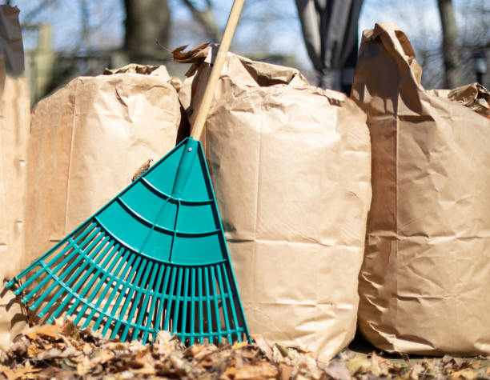
VILLAGE 7 LEAF & BRUSH PICK UP INSTRUCTION
The Village provides removal of brush and bags for our residents. Paper bags are available in the office for purchase. Please take advantage of this service. There are several guidelines for you to follow to make this as efficient as possible.
- Brush and bags must be out the night before or by no later than 6:30 AM the morning of Thursday’s pick up.
- Raking and/or blowing the leaves to the curbs is NOT PERMITTED and will not be picked up by the Village.
- There will be no return trips or doubling back for calls regarding missed pickups or late callers. There are 6 workers on the trucks doing the pick ups and is highly unlikely that we are missing any piles or bags.
- Typically, there are 2-3 vehicles making the rounds, one dedicated for brush with a wood chipper in tow and one for bags.
- Brown paper recyclable lawn and leaf bags are the only types of bags permitted to be picked up and used for yard clean ups.
- These bags are for leaves, pine needles, acorns and pine cones only.
- The workers will leave your bags if there is evidence of improper materials stored; sticks, planters, excessive soil, rocks, etc. The intended materials are not heavy and should not make the bags heavy enough where the workers struggle to get them in the truck.
- These rules are promulgated by Manchester Township and they can revoke our dumping privileges if they are not abided by.
- Brush is to be left in neat piles by the curbside, on the lawn.
- The brush will be picked up and chipped up as we make our way.
- Excessively large piles of brush may not be picked up. If it appears that the brush piles were left by a subcontractor, a call will be placed to the resident, as it is obvious when this occurs.
- No tree stumps of any kind are accepted.

